“We hereby declare that we have read this thesis and in our

opinion this thesis is suffcient in term of scope and quality for the

award of the degree of Doctor of Philosophy (Computer Science)”

|  |  |  |
| --- | --- | --- |
| Signature | : | ________________________________ |
| Name of Supervisor I | : | PROF. DR. MOHD AIZAINI MAAROF |
| Date | : | November 2016 |
|  |  |  |
|  |  |  |

*Notes: If you have more than one supervision, click on the last row of table, then click the plus ‘+’ icon to additional field (delete this line if you already read it)*

ON-LINE RECOGNITION OF DEVELOPING CONTROL CHART PATTERNS

ADNAN BIN HASSAN

A thesis submitted in partial fulfilment of the

requirements for the award of the degree of

Doctor of Philosophy (Computer Science)

Faculty of Mechanical Engineering

Universiti Teknologi Malaysia

November 2016

DECLARATION

I declare that this thesis entitled *“title of the thesis”* is the result of my own research except as cited in the references. The thesis has not been accepted for any degree and is not concurrently submitted in candidature of any other degree.

|  |  |  |
| --- | --- | --- |
| Signature | : | .................................................... |
| Name | : | Click or tap here to enter text. |
| Date | : | 10 November 2016 |
|  |  |  |

DEDICATION

This thesis is dedicated to my father, who taught me that the best kind of knowledge to have is that which is learned for its own sake. It is also dedicated to my mother, who taught me that even the largest task can be accomplished if it is done one step at a time.

ACKNOWLEDGEMENT

In preparing this thesis, I was in contact with many people, researchers, academicians, and practitioners. They have contributed towards my understanding and thoughts. In particular, I wish to express my sincere appreciation to my main thesis supervisor, Professor Dr. Mohd Shariff Nabi Baksh, for encouragement, guidance, critics and friendship. I am also very thankful to my co-supervisor Professor Dr Awaluddin Mohd Shaharoun and Associate Professor Dr. Hishamuddin Jamaluddin for their guidance, advices and motivation. Without their continued support and interest, this thesis would not have been the same as presented here.

I am also indebted to Universiti Teknologi Malaysia (UTM) for funding my Ph.D study. Librarians at UTM, Cardiff University of Wales and the National University of Singapore also deserve special thanks for their assistance in supplying the relevant literatures.

My fellow postgraduate student should also be recognised for their support. My sincere appreciation also extends to all my colleagues and others who have provided assistance at various occasions. Their views and tips are useful indeed. Unfortunately, it is not possible to list all of them in this limited space. I am grateful to all my family members.

ABSTRAK

Kajian ini dilakukan bertujuan mengkaji penggunaan algoritma genetik (GA)

dalam pemodelan sistem dinamik linear dan tak linear dan membangunkan kaedah alternatif bagi pcmilihan struktur model menggunakan GA. Algorithma kuasa dua terkecil ortogon (OLS), satu kaedah penurunan kecerunan digunakan sebagai bandingan bagi kaedah yang dicadangkan. Pcmilihan struktur model mengunakan kaedah algoritma genetik yang diubahsuai (MGA) dicadangkan dalam kajian ini bagi

mengurangkan masalah konvergens pramatang dalam algoritma genetik mudah (SGA). Kesan penggunaan gabungan operator MGA yang berbeza ke atas prestasi model yang terbentuk dikaji dan keberkesanan serta kekurangan MGA diu t arakan. Kajian simulasi dilakukan untuk membanding SGA, MGA dan OLS. Dengan meggunakan bilangan parametcr dinamik yang setara kajian ini mendapati, dalam kebanyakan kes, prestasi MGA adalah lebih baik daripada SGA dalam mencari penyelesaian yang berpotensi dan lebih berkebolehan daripada OLS dalam menentukan bilangan sebutan yang dipilih dan ketcpatan ramalan. Di samping itu, penggunaan carian tcmpatan dalam MGA untuk menambah baik algorithma tersebut dicadang dan dikaji, dinamai sebagai algoritma mcmetic (MA). Hasil simulasi menunjukkan, dalam kebanyakan kes, MA berkeupayaan menghasilkan model yang bersesuaian dan parsimoni dan mcmenuhi ujian pengsahihan model di samping mcmperolehi beberapa kelebihan dibandingkan dengan kaedah OLS, SGA dan MGA. Tambahan pula, kajian kes untuk sistcm berbilang pcmbolehubah menggunakan data eksperimental sebenar daripada dua sistem iaitu sistem pengulang-alik turbo dan reaktor teraduk berterusan menunjukkan algoritma ini boleh digunakan sebagai alternatif untuk mcmperolehi model termudah yang memadai bagi sistcm tersebut.

*Note: use abstract style for this page*

ABSTRACT

The purpose of this study is to investigate the application of genetic algorithm (GA) in modelling linear and non-linear dynamic systems and develop an alternative model structure selection algorithm based on GA. Orthogonal least square (OLS), a gradient descent method was used as the benchmark for the proposed algorithm. A model structure selection based on modified genetic algorithm (MGA) has been proposed in this study to reduce problems of premature convergence in simple GA (SGA). The effect of different combinations of MGA operators on the performance of the developed model was studied and the effectiveness and shortcomings of MGA were highlighted. Results were compared between SGA, MGA and benchmark OLS method. It was discovered that with similar number of dynamic terms, in most cases, MGA performs better than SGA in terms of exploring potential solution and outperformed the OLS algorithm in terms of selected number of terms and predictive accuracy. In addition, the use of local search with MGA for fine-tuning the algorithm was also proposed and investigated, named as memetic algorithm (MA). Simulation results demonstrated that in most cases, MA is able to produce an adequate and parsimonious model that can satisfy the model validation tests with significant advantages over OLS, SGA and MGA methods. Furthermore, the case studies on identification of multivariable systems based on real experiment t al data from two systems namely a turbo alternator and a continuous stirred tank reactor showed that the proposed algorithm could be used as an alternative to adequately identify adequate and parsimonious models for those systems.

*Note: use abstract style for this page*

TABLE OF CONTENTS

|  |  |  |
| --- | --- | --- |
| **CHAPTER** | **TITLE** | **PAGE** |

DECLARATION iii

DEDICATION iv

ACKNOWLEDGEMENT v

ABSTRAK vi

ABSTRACT vii

TABLE OF CONTENTS viii

LIST OF TABLES x

LIST OF FIGURES xi

LIST OF ABBREVIATIONS xii

LIST OF SYMBOLS xiii

LIST OF APPENDICES xiv

1 INTRODUCTION 1

1.1 Overview 1

1.2 Problem Background 1

1.3 Problem Statement 2

1.4 Research Goal 2

1.5 Research Objectives 2

2 LITERATURE REVIEW 3

2.1 Introduction 3

2.2 Methods and Materials, Statistical, and, Unsupervised Instance 4

2.2.1 Methodology One 4

2.2.1.1 Methodology One and Half and Problem Situation 4

2.2.2 Methodology Two 4

3 RESEARCH METHODOLOGY 6

3.1 Introduction 6

3.2 Research Formulation and Proposed Solution 6

3.3 Research Framework 6

3.3.1 Phase 1 – Enhanced Dynamic Adaptation Skin Detection Model 6

3.3.2 Phase 2 – Enhanced Off-line Skin Detection Model using Supervised and Unsupervised Learning 6

3.3.3 Phase 3 – Hybrid Adaptation Strategy based on Dual Enhanced Skin Detection Models 6

3.4 Datasets 6

3.5 Evaluation Metrics 6

3.6 Conclusion 6

4 PROPOSED METHOD 7

4.1 Introduction 7

4.1.1 Descriptions of the Proposed Method 1 7

4.1.2 Descriptions of the Proposed Method 2 7

4.1.3 Description of the Proposed Methods 3 7

5 EXPERIMENTAL RESULTS AND ANALYSIS 8

5.1 Introduction 8

5.2 Experimental Results 1 8

6 CONCLUSION 9

6.1 Introduction 9

6.2 Research Objectives Revisited 9

6.3 Closing Note 9

REFERENCES 12

APPENDIX A 13

APPENDIX B 14

APPENDIX C 15

LIST OF TABLES

|  |  |  |
| --- | --- | --- |
| **TABLE NO.** | **TITLE** | **PAGE** |

1.1 This is example of table format 2

1.1 This is example of table format 2

2.1 This is example of table format 3

LIST OF FIGURES

|  |  |  |
| --- | --- | --- |
| **FIGURE NO.** | **TITLE** | **PAGE** |

1.2 Example of Inserting the Figure Caption Feature in Insert tabs and Home 2

1.3 Example of Inserting the Figure Caption Feature in Insert tabs and Home 2

1.4 Example of Inserting the Figure Caption Feature in Insert tabs and 2

1.4 Example of Inserting the Figure Caption Feature in Insert tabs and Feature in Insert tabs and Feature in Insert tabs and 2

2.1 Feature in Insert tabs and Home 3

2.2 This is the Example of how to insert a Figure captions is the Example of how to insert a Figure captions is the Example of how to insert a Figure captions 4

*References* > *Captions* > *Insert Table of Figures > Figure*

LIST OF ABBREVIATIONS

|  |  |  |
| --- | --- | --- |
| ANN | - | Artificial Neural Network |
|  | - |  |
|  | - |  |

*Notes: If you have more than one supervision, click on the table, then click the plus ‘+’ icon to additional field (delete this line if you already read it)*

LIST OF SYMBOLS

|  |  |  |
| --- | --- | --- |
| δ | - | Minimal error |
|  | - |  |

*Notes: If you have more than one supervision, click on the table, then click the plus ‘+’ icon to additional field (delete this line if you already read it)*

LIST OF APPENDICES

|  |  |  |
| --- | --- | --- |
| **APPENDIX** | **TITLE** | **PAGE** |

# 

## INTRODUCTION

### 1.1 Overview

Lorem Ipsum is simply dummy text of the printing and typesetting industry. Lorem Ipsum has been the industry's standard dummy text ever since the 1500s, when an unknown printer took a galley of type and scrambled it to make a type specimen book.

Lorem Ipsum is simply dummy text of the printing and typesetting industry. Lorem Ipsum has been the industry's standard dummy text ever since the 1500s, when an unknown printer took a galley of type and scrambled it to make a type specimen book. It has survived not only five centuries, but also the leap into electronic typesetting, remaining essentially unchanged. It was popularised in the 1960s with the release of Letraset sheets containing Lorem Ipsum passages, and more recently with desktop publishing software like Aldus PageMaker including versions of Lorem Ipsum.

### 1.2 Problem Background

Lorem Ipsum is simply dummy text of the printing and typesetting industry. Lorem Ipsum has been the industry's standard dummy text ever since the 1500s, when an unknown printer took a galley of type and scrambled it to make a type specimen book. It has survived not only five centuries, but also the leap into electronic typesetting, remaining essentially unchanged. It was popularised in the 1960s with the release of Letraset sheets containing Lorem Ipsum passages, and more recently with desktop publishing software like Aldus PageMaker including versions of Lorem Ipsum.

### 1.3 Problem Statement

### 1.4 Research Goal

### 1.5 Research Objectives

**Figure**

1.2 Example of Inserting the Figure Caption Feature in Insert tabs and Home

**Figure**

1.3 Example of Inserting the Figure Caption Feature in Insert tabs and Home

**Figure**

1.4 Example of Inserting the Figure Caption Feature in Insert tabs and

**Figure**

. Example of Inserting the Figure Caption Feature in Insert tabs and Feature in Insert tabs and Feature in Insert tabs and

**Table**

1.1 This is example of table format

**Table**

. This is example of table format

## LITERATURE REVIEW

### 2.1 Introduction

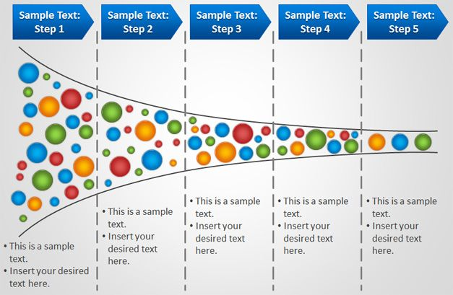

**Figure**

. Feature in Insert tabs and Home

Figure 2.1 shows the features in the *Insert* and *Home* tabs

**Table**

. This is example of table format

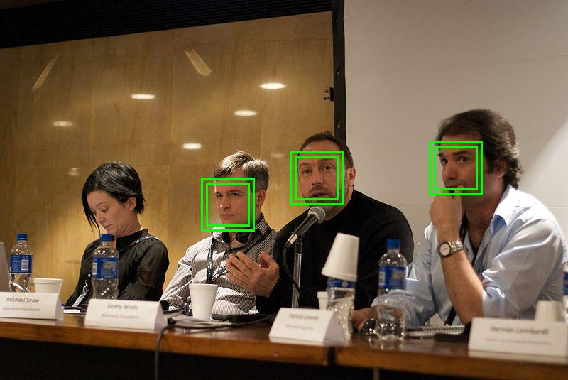

**Figure**

. This is the Example of how to insert a Figure captions is the Example of how to insert a Figure captions is the Example of how to insert a Figure captions

### 2.2 Methods and Materials, Statistical, and, Unsupervised Instance

#### 2.2.1 Methodology One

##### 2.2.1.1 Methodology One and Half and Problem Situation

#### 2.2.2 Methodology Two

## RESEARCH METHODOLOGY

### 3.1 Introduction

### 3.2 Research Formulation and Proposed Solution

### 3.3 Research Framework

#### 3.3.1 Phase 1 – Enhanced Dynamic Adaptation Skin Detection Model

#### 3.3.2 Phase 2 – Enhanced Off-line Skin Detection Model using Supervised and Unsupervised Learning

#### 3.3.3 Phase 3 – Hybrid Adaptation Strategy based on Dual Enhanced Skin Detection Models

### 3.4 Datasets

### 3.5 Evaluation Metrics

### 3.6 Conclusion

## PROPOSED METHOD

### 4.1 Introduction

#### 4.1.1 Descriptions of the Proposed Method 1

#### 4.1.2 Descriptions of the Proposed Method 2

#### 4.1.3 Description of the Proposed Methods 3

## EXPERIMENTAL RESULTS AND ANALYSIS

### 5.1 Introduction

### 5.2 Experimental Results 1

## CONCLUSION

### 6.1 Introduction

### 6.2 Research Objectives Revisited

### 6.3 Closing Note

REFERENCES

APPENDIX A

**Sample of a table in the text**

APPENDIX B

**Sample of a table in the text**

APPENDIX C

**Sample of the page numbering in landscape mode**